Monitoring Task
Task Description:
Install Prometheus and Grafana on a Linux EC2 machine, connect Prometheus to Grafana, and create a dashboard to view metrics.

Created the Ec2 machine
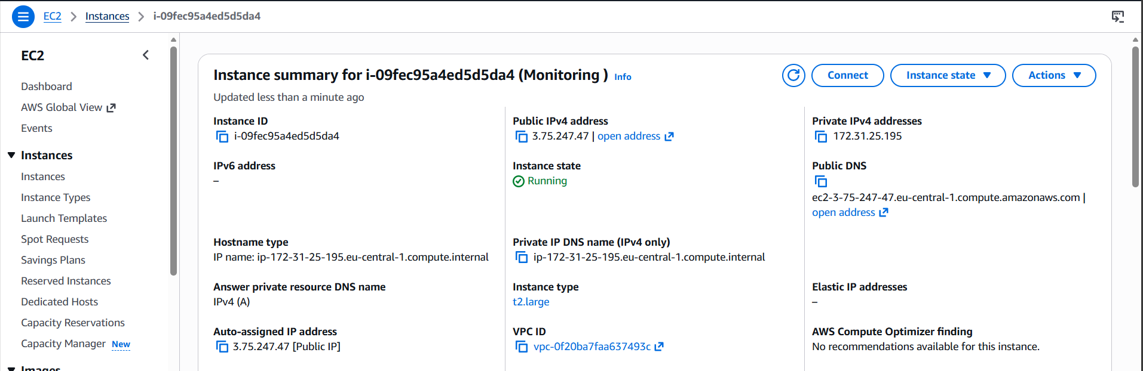
Instance launched
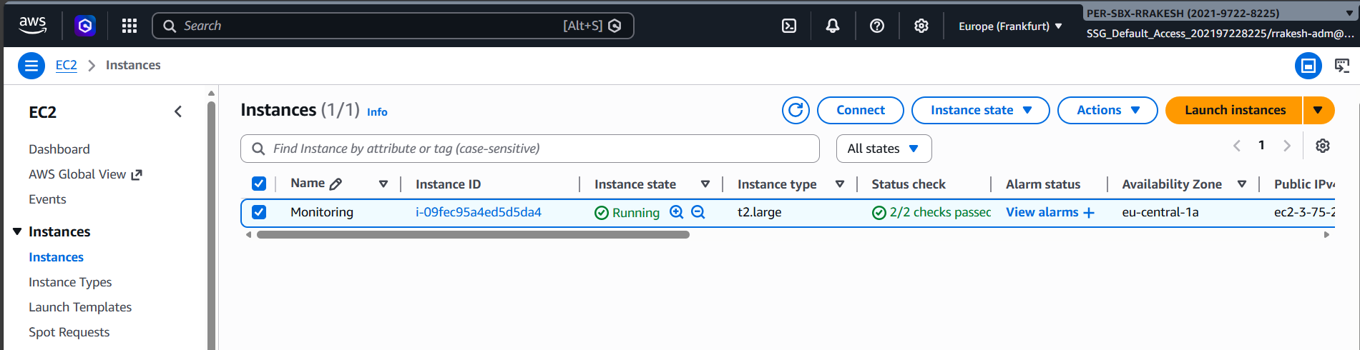

Install Prometheus
Download Prometheus:
wget https://github.com/prometheus/prometheus/releases/download/v2.48.0/prometheus-2.48.0.linux-amd64.tar.gz

Extract it:
tar -xvf prometheus-2.48.0.linux-amd64.tar.gz
cd prometheus-2.48.0.linux-amd64

Start Prometheus

./prometheus --config.file=prometheus.yml
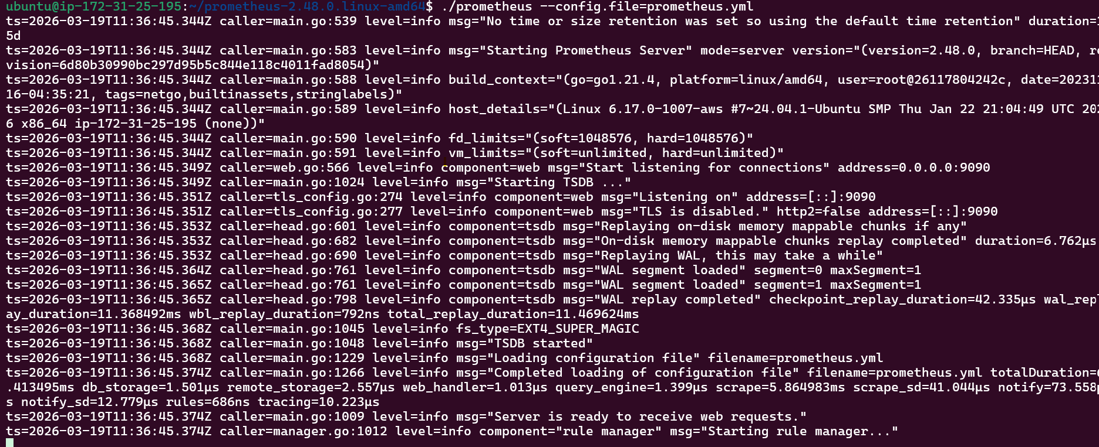

Install Grafana
Add repository:
sudo apt install -y apt-transport-https software-properties-common
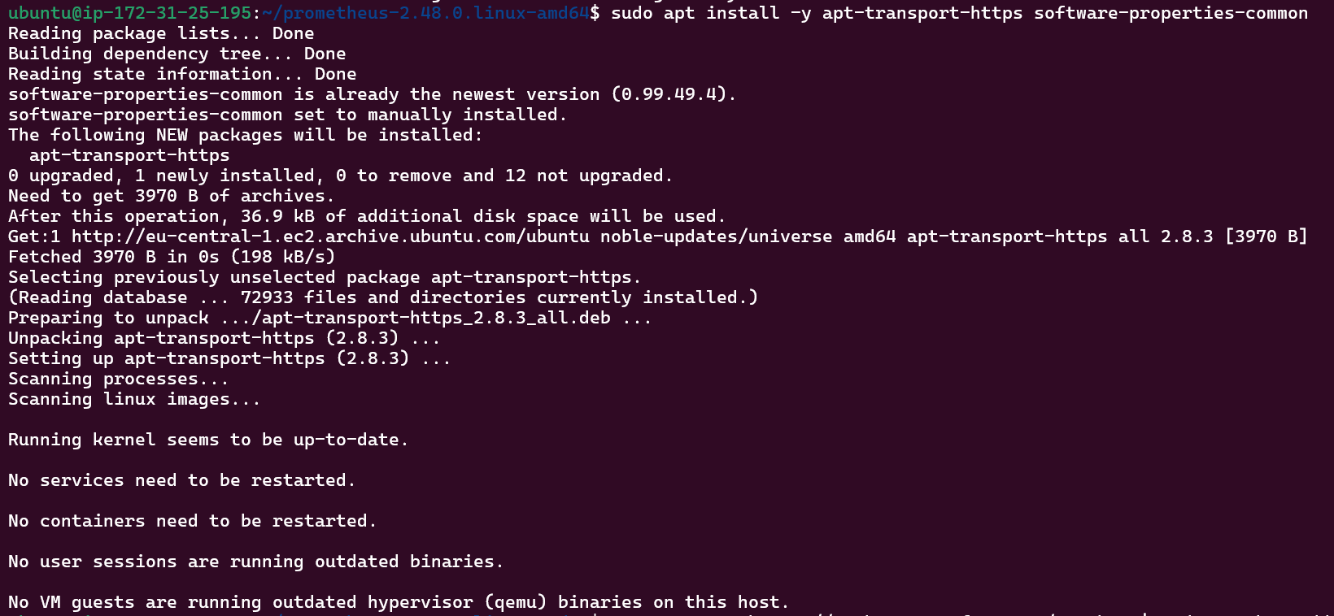
sudo mkdir -p /etc/apt/keyrings
curl -fsSL https://packages.grafana.com/gpg.key | sudo gpg --dearmor -o /etc/apt/keyrings/grafana.gpg
Install grafana
sudo apt update
sudo apt install grafana -y
sudo systemctl start grafana-server
sudo systemctl enable grafana-server
sudo systemctl status grafana-server
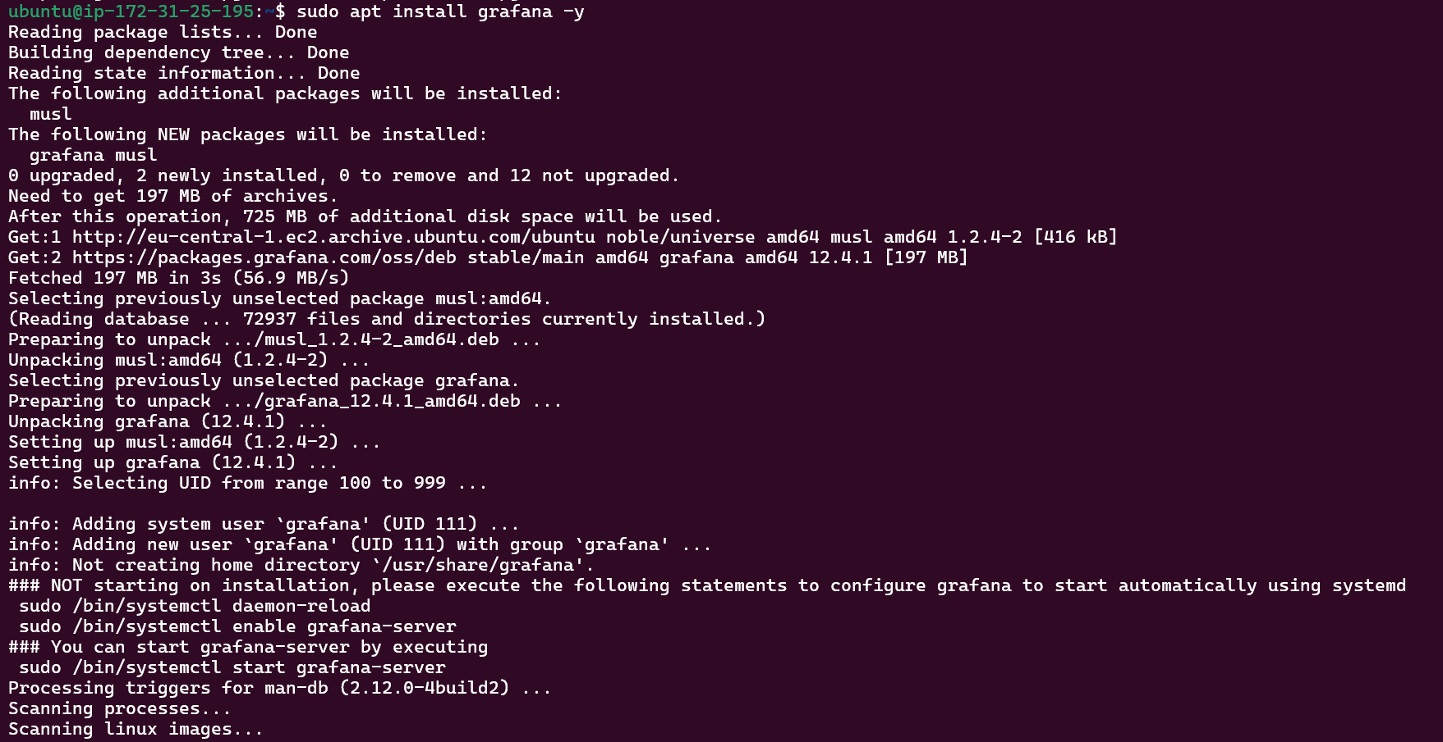

Connect Prometheus to Grafana
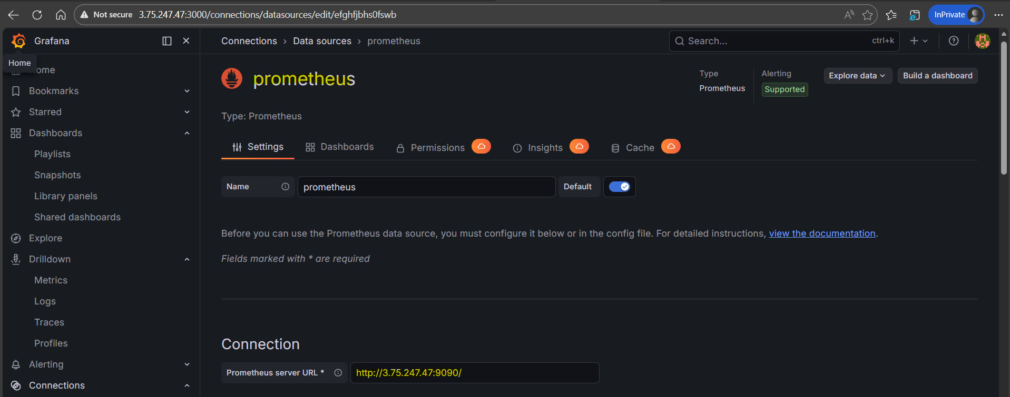
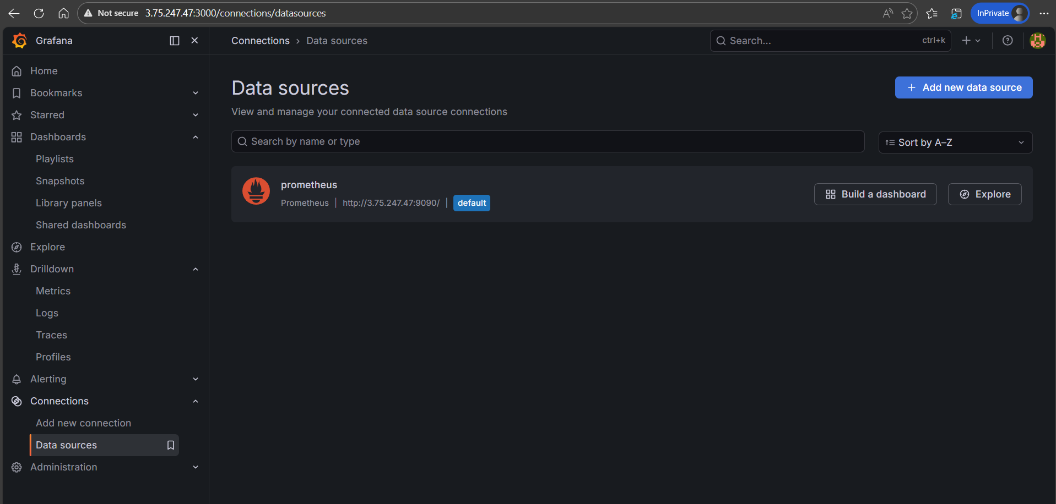

Dashboard to view metrics

